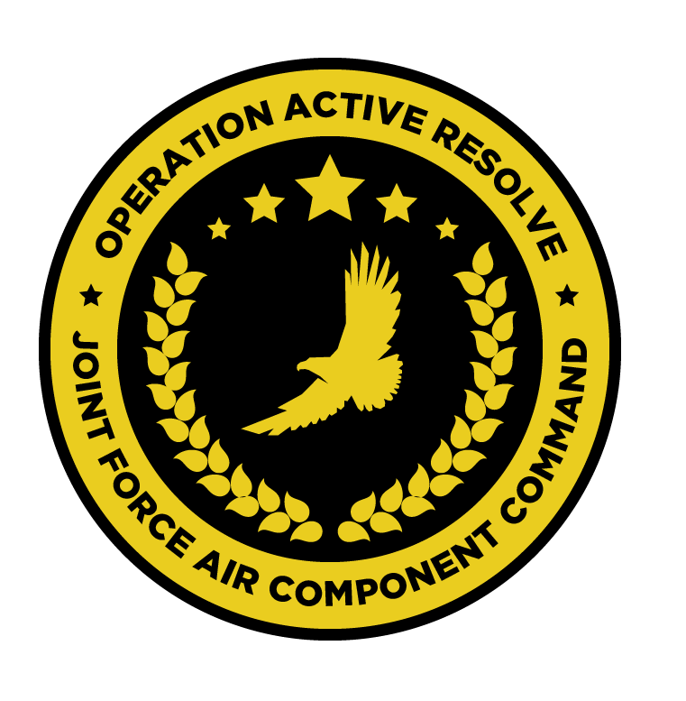

OPERATION ACTIVE RESOLVE SPECIAL INSTRUCTIONS (SPINS)

# Summary of Changes:

Version 1.0: Initial version

# Introduction

## Scope

These SPINS outlines those procedures applicable to the safe effective operations of aircrafts participating in Operation Active Resolve (OPAR). Note: These SPINS will not replace each participating squadron own SOP’s but will make sure that all participating pilots have a common understanding on how to operate during OPAR.

## Deviations

Deviations from these procedures require specific approval from participating squadrons/organizations and need to be briefed to all relevant actors.

## Precedence.

These SPINS take precedence over unit SOP’s. This to ensure a safe environment for all aircrew participating in 132nd Virtual Wing hosted events.

## Recommended changes.

Recommendations for changes to these SPINS should be addressed at the 132nd Virtual Wing forums.

## Changes.

Changes made in this document will be made visible in the following format:

Added text and ~~deleted text~~

Only changes from one version to the next will have these markings.

# General Information

## Timezone.

Timezone for all timings will be UTC+4 Hours (local Georgian time). The reference time will be provided by the military global positioning systems or hacks received from C2 agency (AWACS/GCI) for all assets.

## Standard Units.

### Positions

Positions will be given in the following format: LAT/LONG: DD°MM.MMM'

### Distance

Distance will be given in nautical miles.

### Elevation

Elevation will be given in feet AMSL unless otherwise stated

## Reference documents

### Close Air Support (CAS)

The following document outline how CAS are conducted in OPAR:

[132-TTP-1 CAS Manual v1.2](https://www.dropbox.com/s/p9jirjxt00ri23k/132-TTP-1%20CAS%20Manual%20v1.2.pdf?dl=0?dl=0)

### Armed Reconnissance (AR)

The following document outline how AR are conducted in OPAR:

[132-TTP-12 Armed Reconnaissance v1.0](https://www.dropbox.com/s/0020j7nv0gaeav6/132-TTP-12%20Armed%20Reconnaissance%20v1.0.pdf?dl=0)

### Strike Coordination And Reconissance (SCAR)

The following document outline how SCAR are conducted in OPAR:

[132-TTP-6 SCAR v2.0](https://www.dropbox.com/s/fgjn3wgn5aoit5w/132-TTP-6%20SCAR%20v2.0.pdf?dl=0)

### Air Interdiction (AI)

The following document outline how AI operations are conducted in OPAR:

[132-TTP-13 Air Interdiction v1.0](https://www.dropbox.com/s/b7ppa1vzba778f0/132-TTP-13%20Air%20Interdiction%20v1.0.pdf?dl=0)

### AWACS

The following document outline how integration and cooperation with AWACS is conducted in OPAR:

[132-TTP-10-AWACS Procedures v2.0](https://www.dropbox.com/s/udeqz9vxqawkiui/132-TTP-10-AWACS%20v2.0.pdf?dl=0)

## ATO publication.

ATO will be published at: http://132virtualwing.org/index.php/page/ato

Note that the ATO is visible 72 hours before event start.

# Command and Control (C2)

During operations flightleads will be responsible for their flights.

During operations package commanders will be in charge of a package of flights

On AR missions with multiple flights, AR flights will normally be directed by a SCA flight. If not SCAR flight is present, best suited flight should assume the role of SCAR to coordination the operation ensure safe and effective operations.

All flights shall follow ATC and Controller instructions. All flights are to monitor ATC frequencies when within an airfields airspace control zone.

All flights shall remain on a C2 frequency at all times, unless approved by a C2 agency to do something else. (C2 frequency: Ground/Tower/Approach/AWACS)

### Flightplan

All flights are to file a flightplan prior to the mission. Flightplan should contain airbase you are taking off from, where you are flying, what mission /task you are conduting, and airbase you are landing at. The flightplan can also include the flights loadout. Flightplans are used by controllers during the flight.

### SADL information.

Every squadron is assigned SADL Group ID's in section 11 of this document. Flights will use their flight number for Own ID's. For example: TUSK 2-1 and 2-2 will use a OID of 21 and 22.

### Authentication.

Authentication will be conducted with AET-100. Backup is RAMROD. RAMROD can be found under section 9.6.1

### Transmission authentication.

Transmission authentication will be conducted using the TAT-101.

### Frequencies.

All flights will be assigned a primary and secondary frequency in the ATO. Frequency table is available on 132nd website in the documents section.

### IFF

Flights will be assigned IFF codes in the ATO , availeble on the 132nd website.

### Laser Codes

Flights will be assigned Lasercodes codes in the ATO , availeble on the 132nd website.

### TACAN

Flights will be assigned TACAN codes in the ATO , availeble on the 132nd website.

## C2 Frequencies

### AWACS frequencies

These frequencies are used by AWACS to control aircraft.

Check-in:

In Flight Report Net

Air Request Net

CSAR Net

VHF Backup

Ground Alert frequency (Scramble frequency)

### Tactical frequencies

These frequencies are used by either AWACS or Mission Commanders / Flight Leads to use for the actual tactical execution of the mission (packages, SCAR, etc).

Tactical 1

Tactical 2

Tactical 3

Tactical 4

Tactical 5

Tactical 6

Tactical 7

Tactical 8 (VHF)

Tactical 9 (VHF)

Tactical 10 (VHF)

### JTAC frequencies and callsigns

JTAC HITMAN

JTAC SPARTAN

JTAC WARRIOR

# Air to Air Instructions

## Identification terms.

In OPERATION ACTIVE RESOLVE the following identification terms will be used:

### Hostile.

Bandit that has completed a hostile act or shown hostile intent and may be engaged.

### Bandit.

Aircraft identified as an enemy with current ROE and Identification criteria. Aircraft may be engaged.

### Bogey.

Unknown contact. Need more investigation,

### Friendly.

### Rider.

Bogey adhering to MRR route. Require additional identification..

### Outlaw

## Identification criteria.

In OPERATION ACTIVE RESOLVE the following ID criteria will be used:

### Lack of friendly requirements.

In order to satisfy lack of friendly requirements, completed checks of identification, friendly flight plan and/or minimum risk route adherence must be accomplished.

* IFF
* Following flightplan
* Communications
* Visually ID to friendly unit (Either visual observation or onboard sensors such as EO)

### Positive enemy indication

* Lack of IFF (SPADES)
* RWR correlation to known enemy unit
* Visual ID to known enemy unit
* Electrooptical ID to known enemy unit
* Pattern/racetrack in known enemy territory
* Point of Origin at enemy airfield or enemy territory (OUTLAW)
* Hostile act/Hostile intent

### Hostile intent / hostile act

* Locking up friendlies in order to engage
* Delivery of A-A or A-G munitions toward any friendlies (Sensors: EO, Visual, RWR)
* Maneuvering to obtain tactical advantage (HOT, with high speed)

## Identification matrix, and Rules of Engagement (ROE) (A-A)

### FRIENDLY:

1 or more Friendly indicators.

### NEUTRAL:

Squawking code 60XX AND adhering to published routes in Air Control Plan (ACP) and lack of enemy indicators.

### BOGEY:

Lack of friendly indicators .

### BANDIT:

Lack of Friendly indicators and 2x positive enemy indications.

### HOSTILE:

Hostile act/Hostile intention .

OR

Lack of Friendly indications AND 3x Positive enemy indications.

## Weapon status.

In OPERATION ACTIVE RESOLVE the following weapon release status will be used:

### WEAPON FREE:

At any target not identified as friendly in accordance with current ROE and Identification matrix.

### WEAPON TIGHT:

At targets positively identified as hostile and bandit.

### WEAPON HOLD.:

In self defense or in response to a formal order.

## Formal order

Formal order is given as “ Commit group XXX, Time now XX:XX I authenticate XC (IAW TAT-101)

## Default status

Unless something else is briefed, the default status is weapons free.

## Self Defense

* Nothing in these ROE negates the right of individual self defense.
* Nothing in these ROE negates a pilots right to take all necessary and appropriate action in unit self defense.

# Offensive operations

## Risk levels

### Low

### Medium

### High

### Extreme

### Standard Acceptable Mission Risk Level

The standard Acceptable Mission Risk Level (AMRL) in OPERATION ACTIVE RESOLVE is MEDIUM. Deviations will be stated in amplifications in flight tasking in the ATO, or on Joint Prioritized Target List (JPTL) for AI operations.

## Target priority grade

### Target priority A

The target is essential for mission success in support of current objectives (or the target is a designated High Value Target, High Payoff Target, or TST).

Target with priority A is crucial to the overall success of the operation.

Target with priority A will have immediate and compelling effects.

Its timeliness as an urgent target for targets with priority A may not exist in the future.

If not targeted, negative consequences may seriously jeopardize future CJTF operations.

### Target priority B

Targets have substantial, but not immediate impact on the battle.

The cascading effects this target provides may not be realized in the future.

If not targeted on this ATO, a significant level of effort may be required later.

If not targeted , negative consequence smay significantly hamper CJTF operations.

### Target priority C

Target with priority C will contribute to the battle, but it is not critical to mission success.

Targeting a target with priority C will further the success of the operation.

Targets with priority C will eventually require targeting due to Combined Joint Force Commanders (CJTF) future plans.

If not targeted on this ATO, negative consequences will probably not impede ongoing operations.

### Target priority D

Target of oppertunity if:

1. other targets not suitable for this ATO.
2. as a backup target

Targets with priority D will have minor contributions to the operation.

Targets with priority D may be required for targeting, but is not time critical.

Targets with priority D will not have a negative impact if not targeted.

## Effects

The following effects may be tasked on the ATO:

### Destroy

1)To damage the condition of the target so that it can not function as intended nor to be restored to a usable condition

2) Damage done to the function is permanen, and all aspects of the function have been affected

3) A function's operation is permanently impaired, and the damage extends to all facets of the function's operation

### Degrade

1) Damage done to the function is permanent, but only portions of the function were affected, that is, the function is still operational, but not fully

2) A functions operation is permanently impaired, but the damage does not extend to all facets of the functions operation.

### Neutralize

1) To render an enemy weapon systen and maneuver unit ineffective or unusable for a specific period of time

2) To render ineffective, invalid or unable to perform a particular task or function

3) To counteract the activiy or effect of

### Attrit

1) To destroy or kill by the use of firepower (troops for example)

### Disrupt

1) To break apart, disturb or interrupt a function

2) Damage done to the function is temporary, and only portions of the function have been affected

3) A functions operations is imparied over the short term and the damage does not extend to all facets of the functions operations

### Deny

1) To hinder the enemy the use of space, personel or facilities. It may include destruction, removal

2) Damage done to the function is only temporary, but all aspects of the function were affected

3) A function's operations is impaired over the short term, but the damage extends to all facets of the functions operations

### Harass

1) To disturb the rest of the troops, curtail their movement and lower morale by threat of loss.

### Prevent

1) To deprive of hope or power of acting or succeeding

2) To keep from happening to avert

## Close Air Support (CAS)

The following formats are used for CAS operations in OP ACTIVE RESOLVE:

### CAS check-in briefing

|  |
| --- |
| Mission number |
| Number and type of aircraft |
| Position and altitude |
| Ordnance |
| Time on station |
| Capabilities |
| Abort code |

### Area Operations update (AO update)

|  |
| --- |
| Threat |
| Target |
| Friendly situation |
| Artillery activity |
| Clearance authority |
| Ordnance |
| Restrictions |
| Hazards |
| Remarks |

### CAS brief

|  |
| --- |
| Type of control |
| Bomb on target / Bomb on coordinate |
| Ordnance |
| Method of engagement |
|  |
| IP |
| Heading |
| Distance |
| Target elevation |
| Target description |
| Target location |
| Type Mark Laser code: |
| Egress |
|  |
| Remarks |
| Restrictions |

## SCAR

# Tanker information